|  |  |  |
| --- | --- | --- |
| INDEX | CONTENT | PAGE NO |
| 1. | EXECUTIVE SUMMARY | 1 |
| 2. | CURRENT STRATEGIES ASSESSMENT | 2,3 |
| 3. | NEW STRATEGIES ASSESSMENT | 3 |
| 3.1 | VISION | 3 |
| 3.2 | OBJECTIVES | 3 |
| 3.3 | VALUE CREATION | 3 |
| 3.4 | TARGET SEGMENT | 4 |
| 3.5 | PRIVACY, ETHICAL AND LEGAL ISSUES | 4 |
| 3.6 | EXTERNAL PARTNERS | 5 |
| 3.7 | ORGANIZATIONAL MODEL | 5 |
| 3.8 | REVENUE AND COST MODEL | 6 |
| 3.8.1 | REVENUE MODEL | 6 |
| 3.8.2 | COST MODEL | 6 |
| 3.9 | STRATEGIC ALIGNMENT | 7 |
| 4. | RECOMMENDATIONS | 7 |
| 5. | BMC CANVAS | 8,9 |
| 6. | REFERENCES | 8 |

1. **Executive Summary:**

Richard Liu the co-founder and the CEO of the company JD.com started his journey from Zhong Guan Cun in Beijing ( also referred as the silicon valley of china ) with an handful amount of RMB 12,000 opening a small counter of magneto optical products (Chan, Huanyong Chen and Zhao, 2018). The company took its first step in e-business market on January 2004 where its B2C site went online as jdllaser.com(Chan, Huanyong Chen and Zhao, 2018). The aim is to provide the best quality, authenticity and fast delivery to the online shopping consumers/customers from a wide range of products. The company becomes China’s largest online retailers in selling 3C (computer, communication and consumer electronics) products(Chan, Huanyong Chen and Zhao, 2018). It has also diversified its products by selling online books and even providing the same advantages to the Chinese customers/consumers living overseas. Along with the journey various competitors/rivals like Tencent, Alibaba tries to move ahead/compete with JD in various segments. In order to be ahead in the race there are few new strategies to be kept in mind for JD.com .

1. **Current Strategies Assessment:**

Along with its main rivalry Alibaba JD’s core focus was to stay ahead in the competition with its goal to provide a better customer satisfactory in the field on online shopping. Following are some strategic points of the company:

* The company expanded and became the largest agent of magneto optics.
* With the effect of SARS the company’s BSC site came online and took the first step towards e-business. (Chan, Huanyong Chen and Zhao, 2018)
* Diversified its products and became the largest retailers in 3C products ( computer, communication, consumer electronics). (Chan, Huanyong Chen and Zhao, 2018)
* They got listed in NASDAQ . (Chan, Huanyong Chen and Zhao, 2018)
* They completed four rounds of fund raising with a total of US$2.23bn. (Chan, Huanyong Chen and Zhao, 2018)
* The company developed three core business 1) e-business 2)Finance and 3) Logistics. (Chan, Huanyong Chen and Zhao, 2018)
* They own a self built, stronger and unique logistics system which stands ahead as compared to other companies.
* JD launched a crowd funding platform in order to help attract investors for the start ups.
* The company introduced JD Baitiao and JD Crowdfunding in their finance. (Chan, Huanyong Chen and Zhao, 2018)
* By December 2016 the company has 7 centers, 256 warehouses and 6,906 delivery and pickup stations. (Chan, Huanyong Chen and Zhao, 2018)
* They launched an online customer service center.
* They were able to achieve a higher level of customer satisfaction among their existing customers.
* Providing good brand quality among their existing customers.
* Upgrading their products and services provides an advantage to attract even more customers in the market. (Fern Fort University, 2019)
* Much better dealer community in which the dealer provides information about the company’s launched products to the customers. (Fern Fort University, 2019)
* They have a trustworthy and strong distribution network that would help to reach its potential market. (Fern Fort University, 2019)
* With easy flow of cash the company can easily have the resources in order to expand its projects. (Fern Fort University, 2019)
* As a result they have a better execution of the projects in order to achieve the target revenue.
* Innovation of new products causes more attraction to the customers.
* Flow of new customers as the company is investing a huge amount in the online shopping.
* Reducing the cost of transportation because of lower shipping prices resulting in a decrease of the company’s products would be an advantage. (Fern Fort University, 2019)
* Diversified ideas of the customer would provide a benefit to the company’s progress. (Fern Fort University, 2019)
* The evolving technology provides a benefit for the company as they can practice on its various prices and products.

1. **New Strategies:**

The new strategies of the company depicts the changes made in the organization in order to excel or become better in their competition. It includes

1. Vision
2. objectives
3. Value Creation
4. Target Segment
5. Privacy, Ethical and Legal issues
6. Target Segment
7. External partners
8. Organizational model
9. Revenue and cost model
10. Strategic alignment
11. Recommendation

The following presents step by step representation of the new strategy.

* 1. **Vision:** The vision statement gives a clear idea of what the company sees itself after a particular time period.

The vision of JD.com is given below

The main focus of the JD.com is to provide a better quality satisfaction and authenticity to their customer who are buying their goods online with no fakes. It also focuses on delivering the products on time with safety and also to make the customer experience better than the rival companies. The company strives to become the most trusted brand in the world.

* 1. **Objectives**: The objective statement gives the aim of what the company wants to achieve

Following are the objectives of JD.com

* To own a self built logistics system as an advantage over rival companies.
* To gain the trust of the customers they provided an instant communication mechanism to communicate between the online visitors and JD by launching an online customer service center in January 2001. (Chan, Huanyong Chen and Zhao, 2018)
* To provide a faster delivery at your door step within 3 hours from the moment the order was taken online by the consumer. (Chan, Huanyong Chen and Zhao, 2018)
* To make internet finance go hand in hand with e-business.
* Introduced JD Crowdfunding and JD Baitiao for internet finance. (Chan, Huanyong Chen and Zhao, 2018)
  1. **Value Creation**: It describes what value does the company wants to create.

Following are listed the values offered by JD.com

* Provides access to vivid consumer products and even to the international brands across the world
* Provide authenticity to the customers
* Provide quality assurance
* Fast, safe and reliable delivery of the product to the doorsteps of the customer
* Provide customer satisfaction
* Provide value added fulfillment to the customers
  1. **Target Segment**: The target segment defines what category of customers/people the company wants to target.

The target segment for the JD.com is listed below

As E-business flourished in China and so is the increase of the users using internet for online shopping. In June 2016 the number of users using internet increased to 710 million and that is 51.7 percent of the country’s population (Chan, Huanyong Chen and Zhao, 2018). The numbers were steadily increasing with the growth of e-commerce. The consumers preferred online shopping more and more as they could get anything they want delivered at their footsteps. As a result 92.4 percent of the users uses mobile phone in order to connect with the internet and 401 million of them used mobile devices to shop online products (Chan, Huanyong Chen and Zhao, 2018). People of various age groups from small children, adults to older aged people use the mobile devices to order various goods online .

* 1. **Privacy, Ethical and Legal issues**

The privacy, ethical and legal issues are tackled by the company incase of any occurrence of threat or violation of any code of conduct by the employees.

Below are listed the privacy, ethical and legal issues of JD.com

* The employee can’t use the corporate property or information of his/her in order to seize any opportunity that is beneficial to the company. (Ir.jd.com, 2019)
* The employee of a particular business can’t compete with the company itself. (Ir.jd.com, 2019)
* The employee can’t keep any financial interest though directly or indirectly through a family member or a spouse. (Ir.jd.com, 2019)
* The employee can’t have any ownership interest towards the company. (Ir.jd.com, 2019)
* It is an offence to leak the private/useful data of the company. (Ir.jd.com, 2019)
* The company shouldn’t sell or advertise the malicious content on the internet for its users.
* To prevent leakage of personal information or data of the user while online shopping.
* The entire network should be protected to minimize the risk of hack.
* Content displayed on the website should be kept authentic for each and every product.
* Data privacy should be kept in mind.
* Virus free environment.
* Prevent complexity of the content.
* Care should be taken to avoid the chances of theft, damage or any kind of misuse of the property of the company. (Ir.jd.com, 2019)
* Instant report should be done if there is an actual theft, damage or misuse of the company property. (Ir.jd.com, 2019)
* All the hardware devices should be very well protected incase of some misuse of it.
* Employee must undergo a process if he/she violates or breaks any kind of rules or policy of the company intentionally. (Ir.jd.com, 2019)
* Some serious measures must be taken if the employee uses any user data for his/her on purpose or own advantage.
* Proper code of conduct should be established and followed by each employee of the company.
  1. **External partners:**

JD.com China’s largest e-commerce company by revenue has diversified its products for the customers with an aim to provide better quality and authenticity to its customers. As a result on July 2016 Beijing, the company made its partnership with many of Japan’s leading home and kitchen brand companies like Tiger, Pearl Life and Nishikawa Sangyo. As a result, now the company is selling various home made and kitchen appliances to all of their Chinese customers along with a super fast delivery service. The company has expanded even more of its products which is a plus point in the competition to its rivals. (JD.Com, Inc., 2019)

* 1. **Organizational model**

Organizational model defines the step by step flow of control of the organization.

Following given model comprises of four main sectors of the organization listed below:

* Support/operational sector
* Finance/administration sector
* Marketing sector
* Development sector

1. **Support/Operation sector:** It provides support and executes various operations to be performed for the company. Incase of any emergency or threat this section takes care of it.
2. **Finance/Administration sector**: It handles the finance marketing or operations for the development of the company. Keeps track of the transaction that is being done by the company.
3. **Development sector**: This sector works on various plans or steps to be executed keeping in mind the progress or development of the company. Various research and development is being done under this section. Product innovation plays a major role in this area.
4. **Marketing sector**: It plays a crucial role as it decides the marketing strategy or invents various innovative ideas for the company in order to excel in the competition.

Each employee is skilled in his/her area of expertise. The work gets divided in each sector and to their particular employees related to it. Each sector has a particular person in charge to take care of the data handling and takes care incase of any data leakage that are being processed. As the task gets distributed into each sectors it provides an ease and efficiency to the company. As a result it minimizes the work load in each sector or on each individual.

* 1. 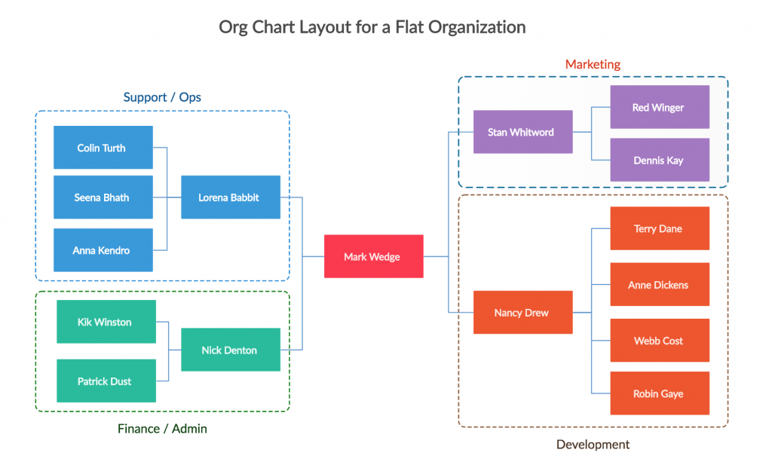 **Revenue and Cost Model**

Organizational model 1(Google.com, 2019)

**3.8.1 Revenue Model**: The revenue model gives you a framework for generating the revenues. It also identifies the source from which the revenue is generated.

Following are the list of revenues associated with the new strategy implemented: (Vizologi | rethinking business model design, 2019)

* Selling of the products
* From the fast and safe delivery system
* Advertisements of the products
* From the self built logistics system
* By taking commission from the third parties

**3.8.2 Cost Model**: The cost model is mainly a mathematical equation to estimate the costs of each and every product.

Following is the cost associated with the new strategy implemented: (Vizologi | rethinking business model design, 2019)

* Infrastructure of the company
* Built-in offices
* Number of employees
* Hardware components
* Various kinds of facilities provided
* Logistics system network
* Marketing techniques
* Vivid types of advertisement platforms
* The cost of vivid products
* Distribution networks
* Distribution cost
* Marketing cost
* Employee salary
* Commission taken from third parties
  1. **Strategy Alignment of the company:**

Strategic alignment is a step by step process of linking all the organization’s resources, structure along with its strategy and environment to have a positive output or impact in the end.

* From the above stated steps we can say that healthy partnership of the company with the external partners would provide a great benefit for the company and will result a great impact in the output.
* From the above shown model doing proper, innovative marketing and advertising of the upcoming/existing products will result to increase in the revenue of the company.
* An efficient hardworking team of the company plays a major role in the success and development of the company. (Techinasia.com, 2019)
* With an easy flowing and strong chain of supply results in increase in the sales and revenue of the company. (Techinasia.com, 2019)
* By selling authentic products in the market results in a systematic increase in the customer demand and increase in revenue.
* Keeping affordable prices of the products results in attracting even more customers in buying or shopping online products.

1. **Recommendations**

* Innovation of products must be done on a regular time interval in order to meet the customer needs.
* The quality and the cost of the products should be kept in mind incase of deploying new products to reduce the risk of fakes.
* Consistent improvement of the logistics network will lead to increase in the revenue and sales of the product.
* Customer interaction should be monitored on a daily basis in order to increase the sales of the products.
* Consistent minute and precise changes should be done to the delivery services or network that would result in the benefit of the company.
* The fluctuating demands of the customers should be monitored or noted down.
* Continuous monitoring of the customer feedback should be done on a daily basis to increase the performance of the company.

1. **BMC Canvas:**
2. KEY PARTNERS

* Partnership with Tencent(Vizologi | rethinking business model design, 2019)
* JD’s partnership with Walmart(Vizologi | rethinking business model design, 2019)
* Partnership with various manufacturers and its distribution
* Partnered with Singaporean e-tailer iknow(Chan, Huanyong Chen and Zhao, 2018)
* Various domestics and international brands
* Various tech providers

1. KEY ACTIVITIES

* Distribution
* Marketing
* Finances
* Sales
* Logistics system
* Maintenance network
* Support of customers
* Ecommerce
* Price of the products
* Research and development

1. VALUE PROPOSITIONS

* Maintained quality of products
* Authenticity
* Easier transaction process for customers
* Easier and faster access to various products in the online website
* Customer satisfaction

1. KEY RESOURCES

* Authentic and high quality products
* Online and offline platforms
* The data of the customers
* The delivery person
* Self built logistics network

1. CUSTOMER RELATIONSHIPS

* Online and offline customers
* Fast delivery within 3 hours from order placed(Chan, Huanyong Chen and Zhao, 2018)
* Online and offline customers
* Full time availability for customer services
* Online website

1. CHANNELS

* Various mobile applications
* Through various social media channels
* Advertisements of various products online

1. CUSTOMER SEGMENTS

* Chinese customers
* Overseas Chinese customers
* Individual customers
* Buyers
* Suppliers

1. COST STRUCTURE

* Offices
* Infrastructures/buildings
* Hardware components
* Employees of the company
* Salary
* Buyers
* The cost of products
* From its logistics system
* Various forms of advertisements
* Various forms of marketing
* Its distribution network

1. REVENUE STREAMS

* From advertisements of various products
* Its self built logistics system(Vizologi | rethinking business model design, 2019)

1. **References:**
2. Chan, A., Huanyong Chen, C. and Zhao, L. (2018). JD.com: leveraging the edge of e-business. *Emerald Emerging Markets Case Studies*, 8(3), pp.1-30.
3. Fern Fort University. (2019). *JD.com, Inc. Porter Five (5) Forces & Industry Analysis [Strategy]*. [online] Available at: http://fernfortuniversity.com/term-papers/porter5/analysis/3654-jd-com--inc-.php [Accessed 13 May 2019].
4. Fern Fort University. (2019). *JD.com SWOT Analysis Matrix [step by step] Weighted SWOT*. [online] Available at: http://fernfortuniversity.com/term-papers/swot/1433/1109-jd-com.php [Accessed 13 May 2019].
5. JD.Com, Inc. (2019). *JD.com Announces Partnerships with Leading Japanese Home and Kitchenware Brands | JD.Com, Inc.*. [online] Available at: http://ir.jd.com/news-releases/news-release-details/jdcom-announces-partnerships-leading-japanese-home-and [Accessed 13 May 2019].
6. Ir.jd.com. (2019). [online] Available at: https://ir.jd.com/static-files/05c2573f-81f9-4c5e-88a4-b7546f38216c [Accessed 13 May 2019].
7. Vizologi | rethinking business model design. (2019). *JD.com business model canvas*. [online] Available at: https://vizologi.com/business-strategy-canvas/jdcom-business-model-canvas/ [Accessed 13 May 2019].
8. Google.com. (2019). *types of organisational models of a company - Google Search*. [online] Available at: https://www.google.com/search?q=types+of+organisational+models+of+a+company&rlz=1C1CHBF_en-GBAU843AU844&source=lnms&tbm=isch&sa=X&ved=0ahUKEwjb2syP05XiAhUPXn0KHRoUDp8Q_AUIDigB&biw=1280&bih=578#imgrc=zKelAZF-KXLQqM: [Accessed 13 May 2019].
9. Techinasia.com. (2019). *Tech in Asia - Connecting Asia's startup ecosystem*. [online] Available at: https://www.techinasia.com/6-points-jdcoms-strategic-model [Accessed 13 May 2019].